**Software Requirements Specification**

For

Heart Attack Detector: An IoT based solution integrated with cloud

15th March, 2022

Prepared by

|  |  |  |
| --- | --- | --- |
| **Specialization** | **SAP ID** | **Name** |
| CCVT | 500076357 | Vitesh Sethi |
| CCVT | 500076485 | Shubham Dabas |
| CCVT | 500075845 | Shivam Kumar |



Department of Systemics

School Of Computer Science

UNIVERSITY OF PETROLEUM & ENERGY STUDIES,

DEHRADUN- 248007. Uttarakhand

Table of Contents

|  |  |  |
| --- | --- | --- |
| **Topic** | | **Page No** |
| Table of Content | |  |
| Revision History | |  |
| 1 | Introduction | 4 |
|  | 1.1 Purpose of the Project | 4 |
|  | 1.2 Target Beneficiary | 4 |
|  | 1.3 Project Scope | 5 |
|  | 1.4 References | 5-6 |
| 2 | Project Description | 6-7 |
|  | 2.1 Data/ Data structure | 6 |
|  | 2.2 SWOT Analysis | 6 |
|  | 2.3 Project Features | 6 |
|  | 2.4 Design and Implementation Constraints | 7 |
|  | 2.5 Design diagrams | 7 |
|  |  |  |
| 3 | System Requirements | 8 |
|  | 3.1 User Interface | 8 |
|  | 3.2 Protocols | 8 |
|  |  |  |
| 4 | Non-functional Requirements | 8-9 |
|  | 4.1 Performance requirements | 8 |
|  | 4.2 Security requirements | 9 |
|  | 4.3 Software Quality Attributes | 9 |
|  |  |  |
| Appendix A: Glossary | | 9 |

**Revision History**

|  |  |  |  |
| --- | --- | --- | --- |
| **Date** | **Change** | **Reason for Changes** | **Mentor Signature** |
|  |  |  |  |
|  |  |  |  |
|  |  |  |  |
|  |  |  |  |

1. INTRODUCTION

Nowadays, health issues such as cardiac failure, lung failure, and heart-related diseases are on the rise at an alarming rate. Because of these issues, regular health monitoring is essential. Wireless health monitoring of a patient is a modern concept. It is a significant advancement in the medical field. Using leading technologies such as wireless communications, wearable and portable remote health monitoring devices, health professionals have developed a brilliant and inexpensive health monitoring system for providing more comfortable living to people suffering from various diseases. As information about the patient's health directly reaches the doctor's monitor screen from anywhere the patient resides, doctor visits to patients are constantly decreasing. Furthermore, based on this, doctors can save many lives by providing them with a timely and valuable service. Because of technological advancements in the field of medical science, it has become much easier to determine different parameters of a patient using electronic machines, such as heart rate, temperature, and so on. Heart rate monitoring System is one such electronic device.

Nowadays, health issues such as cardiac failure, lung failure, and heart-related diseases are on the rise at an alarming rate. Because of these issues, regular health monitoring is essential. Wireless health monitoring of a patient is a modern concept. It is a significant advancement in the medical field. Using leading technologies such as wireless communications, wearable and portable remote health monitoring devices, health professionals have developed a brilliant and inexpensive health monitoring system for providing more comfortable living to people suffering from various diseases. As information about the patient's health directly reaches the doctor's monitor screen from anywhere the patient resides, doctor visits to patients are constantly decreasing. Furthermore, based on this, doctors can save many lives by providing them with a timely and valuable service. Because of technological advancements in the field of medical science, it has become much easier to determine different parameters of a patient using electronic machines, such as heart rate, temperature, and so on. Heart rate monitoring System is one such electronic device. According to the 2014 Survey of Sample Registration System (SRS) in Indonesia, Coronary Heart Disease (CHD) is the second leading cause of death at all ages after stroke, accounting for 12.9 percent of all deaths. Because heart attacks are usually detected using special hardware and performed in hospitals, the cause of death is delayed detection. IOT (Internet of Things) technology has recently emerged as one of the technologies with the concept of an object being able to transfer data over a network without the need for human-to-human or human-to-machine interaction. The Internet of Things (IOT) emerged from the convergence of wireless technologies, micro electromechanical systems (MEMS), and the Internet. In this project, the heart attack detection system is proposed which is able to monitor the heart rate using the health heart rate sensor. A sim module is interfaced with the microcontroller in order to trigger a call when there is an abnormal activity captured by heart sensor. The data is stored in the firebase so that doctor can able to access the stored data to monitor the person.

* 1. Purpose of the Project

An IoT-based solution has been developed that can monitor the heartbeat based on the output of a hardware system comprised of a pulse sensor. Further, an alert call system is added which is activated if the heartbeat falls below or exceeds above the permissible level given in the devised algorithm. The call is received by the doctor or caretaker of the patient. By using this prototype the doctors can access the heartbeat data of the patient. The nurses or the duty doctor available at the hospital can monitor the heart rate of the patient through the real-time monitoring system. The heartbeat data and other personal details of the patient are stored in the cloud, this can be utilized for future studies on the health condition of the patient.

1.2 Target Beneficiary

The target beneficiaries of the proposed methodology are the old people who lives without their caretakers. They do not able to call their care takers at the last moment. Healthcare authorities are the main beneficiaries because they are able to remotely monitor the patients.

1.3 Project Scope

The scope of our project is to monitor the heart rate of the patient remotely with the use of cloud computing and IoT. The call is triggered to the care taker when there is an abnormal behavior captured by the sensors. The pulse sensor is used to capture the heart beat which is interfaced with the microcontroller to store the data in the firebase. This methodology is very useful for the healthcare professionals in order to monitor and detect the heart attack of the patient.

1.4 References

[1] I. Journal, S. S. Kazi, G. Bajantri, and T. Thite, “Remote Heart Rate Monitoring System Using IoT,” International Research Journal of Engineering and Technology, 2018, Accessed: Mar. 14, 2022. [Online]. Available: [www.irjet.net](http://www.irjet.net)

[2] V. Goel, S. Srivastava, D. Pandit, D. Tripathi, and P. Goell, “Heart Rate Monitoring System Using Finger Tip through IOT,” International Research Journal of Engineering and Technology, Accessed: Mar. 14, 2022. [Online]. Available: [www.irjet.net](http://www.irjet.net)

[3] N. Patel and P. Patel, “Heart Attack Detection and Heart Rate Monitoring Using IoT,” Nehal Patel International Journal of Innovations & Advancement in Computer Science, 2018, Accessed:Mar. 14, 2022. [Online]. Available: <https://www.researchgate.net/publication/329268152>

[4] D. Balakrishnand, T. Dhiliphan Rajkumart, and S. Dhanasekaran, “An intelligent and secured heart rate monitoring system using IOT,” Materials Today: Proceedings, Dec. 2020, doi: 10.1016/J.MATPR.2020.11.316.

[5] P. Bansal, M. Malik, and R. Kundu, “Smart heart rate monitoring system,” 2018 IEEMA Engineer Infinite Conference, eTechNxT 2018, pp. 1–4, Jun. 2018, doi: 10.1109/ETECHNXT.2018.8385347.

2. PROJECT DESCRIPTION

2.1 Data/ Data structure

* Queue Data structure: It is a linear structure that follows a particular order in which the operations are performed. The order is First In First Out (FIFO).

2.2 SWOT Analysis

Strength: The utmost strength of our project is that it is a real-time heartrate monitoring system and can help in detecting heart attack at an early stage. Also, we have included the features of emergency alert system to the caretaker or the nurse about the same. Further our all details will be uploaded on cloud for the future reference of patient medical history.

Weakness: The only weakness of our project is the hardware connected components in IOT device. Because the components used are suitable for low level usage, though we can still integrate high level components for the same project.

Opportunities: It can have wide range of valid possibility that this project can evolve into some bigger medical project or maybe subsumed under some higher application. This project can also be used for educational purposes, say, for demonstration of working of IOT devices used for medical services.

Threats: Our IOT-based project is susceptible to AI-based attacks. These AI attacks have been around since 2007, the threats they present within IoT are becoming increasingly more prominent. Hackers now can build AI-powered tools that are faster, easier to scale, and more efficient than humans, to carry out their attacks. This poses a serious threat within the IoT ecosystem. While the tactics and elements of traditional IoT threats presented by cyber attackers will look the same, the magnitude, automation, and customization of AI-powered attacks will make them increasingly hard to battle.

2.3 Project Features

The main function of our project is detecting heart attack at an early stage and this diagnosis system is based on real-time monitoring system. Further, an alert call system is also added which is activated if the heartbeat falls below or exceeds above the permissible level given in the devised algorithm. The call is received by the doctor or caretaker of the patient. By using this IOT-based prototype the doctors can access the heartbeat data of the patient. The heartbeat data and other personal details of the patient are stored in the cloud, this can be utilized for future studies on the health condition of the patient.

2.4 Design and Implementation Constraints

* Networking issues
* Storage restrictions
* Complexity in integrating different sensors.

2.5 Design diagram

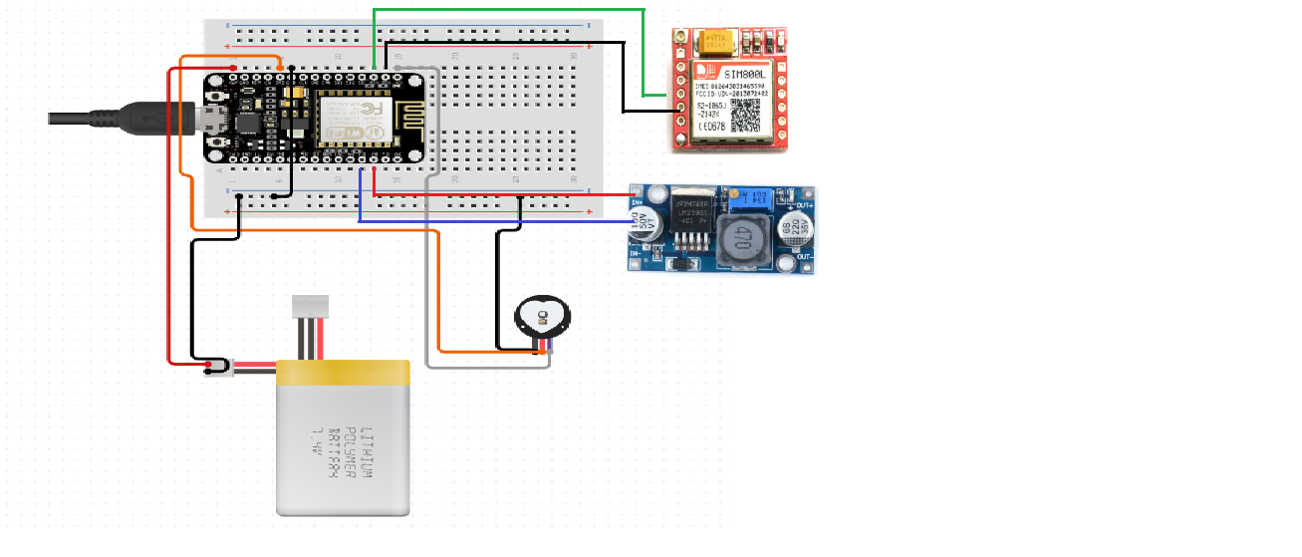

3. SYSTEM REQUIREMENTS

3.1 User Interface

Our project requires a user interface so that it is easier for the users to get their respective data. For this, we have used HTML and CSS to design our front-end which will allow the users to see their heart rate at a particular time and monitor accordingly. As we are using an IoT device to sense the heart rate and send it to the backend where it will be accessed by the database. For the design and implementation of the User Interface, we needed: Visual Studio Code.

3.2 Protocols

Wired Communication protocol:

* + UART: Universal Asynchronous Receiver Transmitter is a hardware communication protocol that uses asynchronous serial communication with configurable speed. Asynchronous means there is no clock signal to synchronize the output bits from the transmitting device going to the receiving end.

IEEE Wireless standard:

* + IEEE 802.11 [Wi-Fi] Wireless LAN Media Access Control and Physical Layer specification. 802.11a, b, g, etc. are amendments to the original 802.11 standard. Products that implement 802.11 standards must pass tests and are referred to as "Wi-Fi certified."

4. NON-FUNCTIONAL REQUIREMENTS

4.1 Performance requirements

The following are the four basic requirements needed:

* Provisioning and Authentication
* Configuration and Control
* Monitoring and Diagnostics
* Software Updates and Maintenance

4.2 Security requirements

Here are some of the security measures we intend to take for our project:

* In this system, a real-time heart rate monitoring and heart attack detection system is realized by using IoT. The proposed design is advantageous to patients of different age groups by providing real-time heart health monitoring. It also provides security and privacy to the data of the patient.
* As we are using Firebase as Baas (Backend as a service), which provides security and privacy to the data as it is a Google platform.

4.3 Software Quality Attributes

Availability: Availability of our project depends upon the availability of individual services used in our project. As we are using Firebase its availability as per Google Service level agreement (SLA) is 99.95 %.

Portability: For our project we used IoT device which is easily portable.

Usability: Techopedia defines usability as the degree of ease with which products such as software and web applications can be used to achieve required goals effectively and efficiently. Usability assesses the level of difficulty involved in using a user interface. Our project provides a simple and friendly web user interface keeping ease-of-use for users in our mind.

Testability: Our project can be easily broken down into sub-components based on the services and device used. Each service of the device can be individually tested and verified for use.

APPENDIX A: GLOSSARY

* Pulse sensor: Pulse Sensor is an Arduino-compatible heart-rate sensor with a well-designed plug-and-play interface. Students, artists, athletes, makers, and game and smartphone developers that wish to include live heartrate data into their work can use it. The sensor attaches to a fingertip or earlobe and connects to Arduino via jumper cables. It also comes with an open-source monitoring app that displays your pulse in real time on a graph.
* ESP8266: The ESP8266 WiFi Module is a self-contained SOC with an inbuilt TCP/IP protocol stack that can provide access to your WiFi network to any microcontroller. The ESP8266 may either host an application or offload all WiFi networking functionality to a separate application processor. An AT command set firmware is pre-programmed into each ESP8266 module.
* SIM800L: The SIM800L is a small cellular module that can send and receive GPRS data, send and receive SMS, and make and receive voice calls. This module's low cost, small footprint, and quad band frequency capabilities make it an ideal choice for any project requiring long-range connectivity.